Sunandan Sharma
ssunandan433@gmail.com
Funnel Performance Analysis
Customer Journey, Conversion & Revenue Analysis using Python and Power BI

Tools: Python | Power BI | DAX
Prepared by: Sunandan Sharma

EXECUTIVE SUMMARY

- Project Overview

This project analyzes an e-commerce customer journey to understand funnel performance, conversion behavior, revenue generation, and user engagement. Using Python for data preparation and exploratory analysis and Power BI for interactive reporting, the analysis evaluates customer movement across the Browse → Add to Cart → Checkout → Purchase funnel.

- Analytical Focus

The analysis focuses on identifying critical funnel drop-off points, evaluating revenue and conversion performance across channels, regions, devices, and product categories, and examining daily and hourly behavioral patterns. Session-level analysis was also performed to better understand customer engagement and progression through the purchasing journey.

- Outcome

The project transforms event-level e-commerce data into actionable business insights through Python-based analysis and an interactive four-page Power BI dashboard. The findings highlight opportunities to reduce funnel leakage, improve conversion efficiency, understand revenue drivers, and support more informed marketing and customer-experience decisions.

BUSINESS PROBLEM & OBJECTIVES

- Business Problem

E-commerce businesses generate large volumes of customer interaction data, but understanding where users disengage before completing a purchase remains a key analytical challenge. This project examines the customer journey from product browsing to purchase to identify funnel leakage, evaluate conversion efficiency, and understand how factors such as acquisition channel, region, device, product category, and user behavior influence business performance.

- Project Objectives

- Analyze the conversion funnel from Browse → Add to Cart → Checkout → Purchase and identify major drop-off points.
- Evaluate channel, regional, device, and product-category performance to understand key revenue and conversion drivers.
- Analyze customer behavior and engagement, including bounce behavior and session duration.
- Identify daily and hourly patterns in traffic and conversion performance.
- Translate analytical findings into actionable business recommendations that could improve conversion efficiency and revenue performance..

DATASET & ANALYTICAL APPROACH

- Dataset Overview

The analysis was performed on an event-level e-commerce dataset containing customer interactions across different stages of the purchasing journey. Each record represents a user event and includes information related to sessions, traffic source, device, geographic region, product category, revenue, bounce behavior, and timestamp.

Dataset Size: 21,663 event records | Unique Sessions: 10,000 | Funnel Stages: 4

- Analytical Workflow

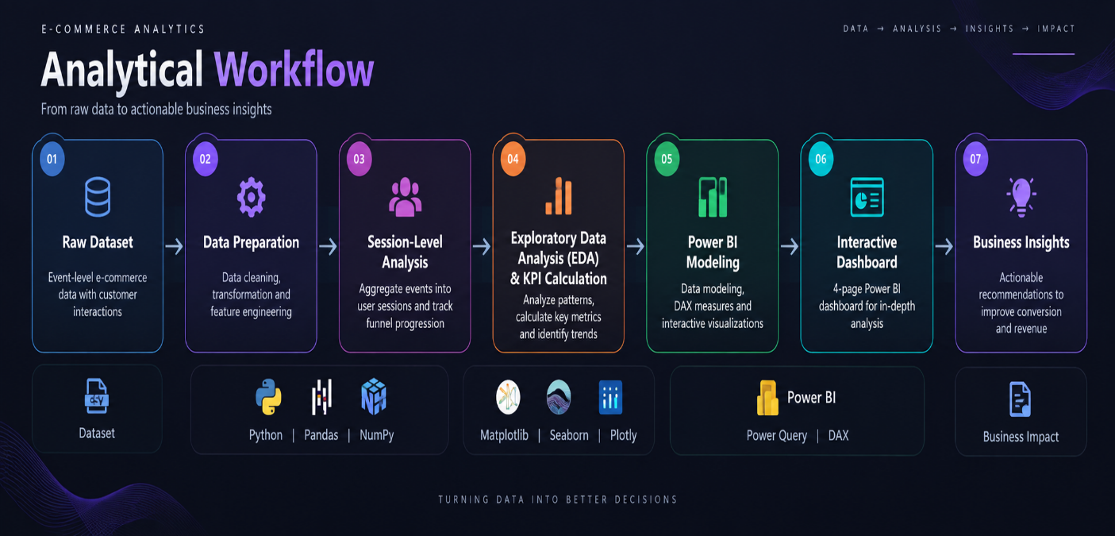

DATA PREPARATION & SESSION ANALYSIS USING - PYTHON

- Introduction

Python was used to prepare and transform the raw event-level e-commerce dataset into an analysis-ready structure. The process included data loading, structural inspection, data-quality checks, feature engineering, and session-level aggregation to enable accurate funnel and behavioral analysis.

- Data Loading & Initial Exploration

Data Loading: The CSV dataset was imported into a Pandas DataFrame for analysis.
Initial Exploration: The dataset was inspected using sample records, column names, data types, summary statistics, and dataset information to understand its structure before performing transformations.
Timestamp Conversion: The Timestamp field was converted to datetime format to support time-based and session-duration analysis.

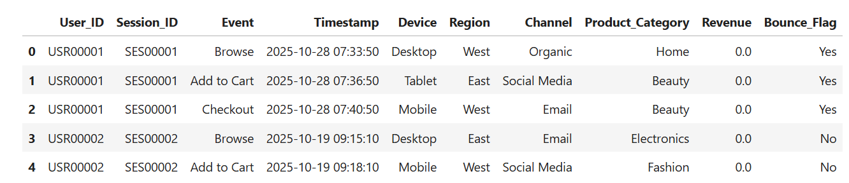

- Data Quality & Feature Engineering
Data Quality Checks: Null values, duplicate records, and unique values were examined to identify potential data-quality issues.
Time-Based Features: New fields including Date, Day of Week, Hour, and Week Number were extracted from the Timestamp field to support temporal analysis.
Event Sequencing: An event sequence was created within each session to track the order of customer interactions.

- Session-Level Aggregation

Since the original dataset was event-level, the data was aggregated by Session_ID to create a session-level analytical dataset. For each session, the analysis captured the session start and end time, sequence of events, device, region, channel, product category, revenue, and bounce status.
Then:
Session Duration was calculated from the difference between session start and end timestamps. A Max Funnel Stage was also assigned to each session to identify the furthest stage reached in the customer journey.
To sum-up:
21,663 Event Records
↓
Group by Session_ID
↓
10,000 Unique Sessions
↓
Determine Maximum Funnel Stage
↓
Session-Level Dataset Ready for Analysis

Exploratory Data Analysis Using Python

- Introduction

Python was used to evaluate funnel progression, conversion efficiency, revenue performance, and user engagement at the session level.

- Funnel & Conversion Analysis

Browse
10,000
→ 70.59% →

Add to Cart
7,059
→ 49.93% →

Checkout
3,524
→ 30.65% →

Purchase
1,080

The largest absolute drop occurred between Add to Cart and Checkout (3,535 sessions), while Checkout → Purchase had the lowest stage conversion rate (30.65%).

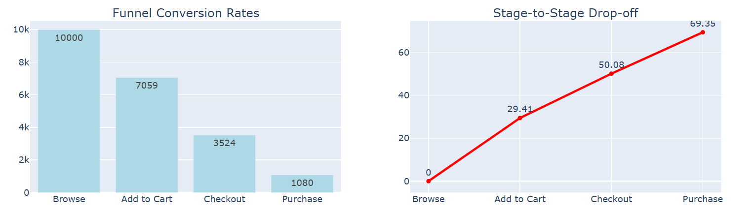

- Performance & Engagement Metrics

Metric |  | Result
 | Overall Conversion Rate |  | 10.80%
 | Total Revenue |  | $1.18M
 | Average Order Value |  | $1.09K
 | Bounce Rate |  | 89.20%
 | Average Session Duration |  | 4.08 min
Engagement Insight: Session duration increased as users progressed deeper into the funnel, with purchasing sessions averaging approximately 10.55 minutes.

Performance & Behavioral Analysis Using Python

- Introduction

Further Performance was compared across acquisition channels, regions, and product categories to identify variations in revenue and conversion behavior. Time-based analysis was also performed to understand changes in customer activity throughout the day and across the analysis period.

- Segment Performance

Channel Performance -
Compare sessions, conversion, and revenue across acquisition channels.

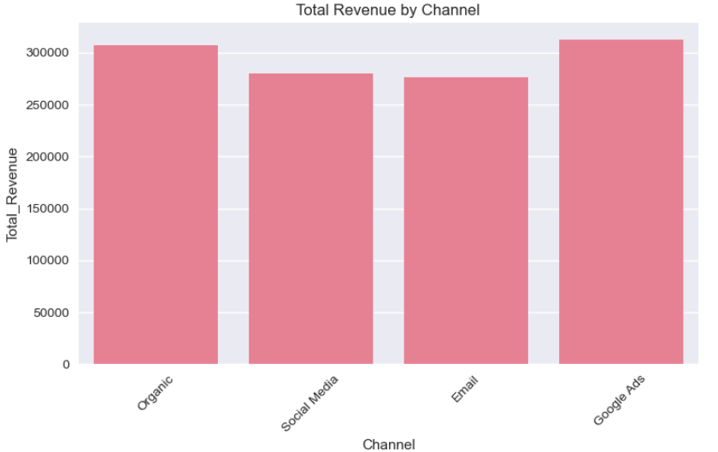

Regional Performance -
Evaluate differences in conversion and revenue across regions.

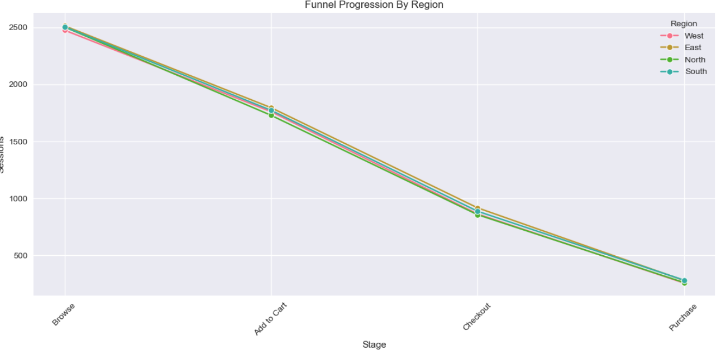

Product Category Performance -
Identify categories contributing most strongly to orders and revenue.

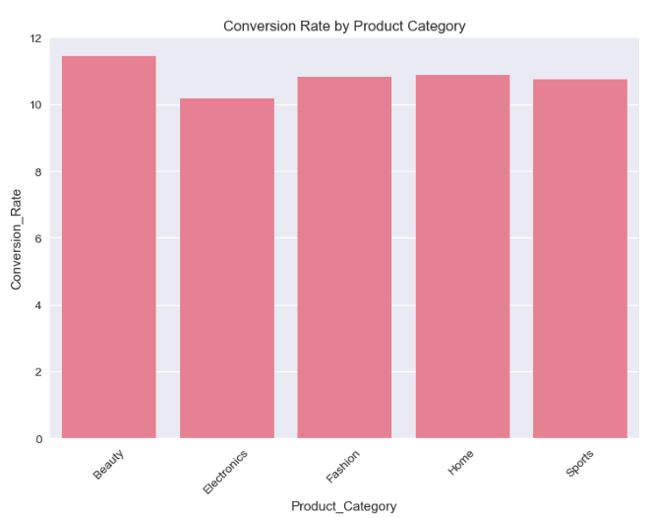

Temporal Behavior Insights -
Traffic and conversion patterns varied over time, with 10 AM recording peak traffic while 3 AM recorded the highest hourly conversion rate

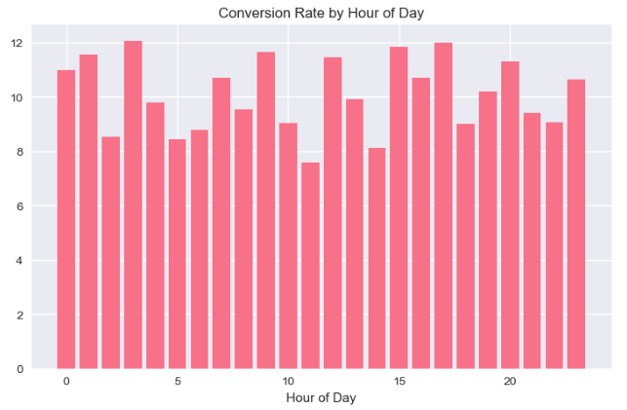

Power BI Development

- Introduction

After completing the exploratory analysis in Python, Power BI was used to transform the analytical findings into an interactive business intelligence dashboard. The focus was on creating reusable DAX measures, interactive filtering, and a structured multi-page reporting experience.

- Data Preparation & Modeling

The event-level dataset was imported into Power BI and prepared using Power Query. The Timestamp field was separated into Date and Time, appropriate data types and formatting were applied, and a dedicated Measures table was created to organize the analytical calculations.

- DAX Measures & Calculations Preparation & Modeling

DAX measures were developed to dynamically calculate key business and funnel metrics under different filter contexts.
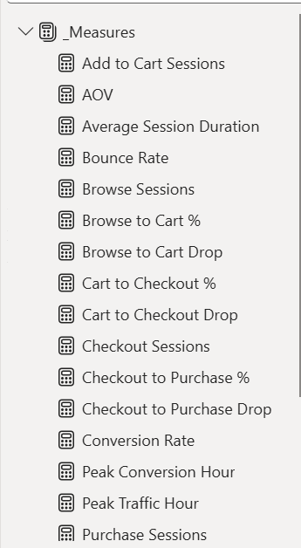

Interactive Power BI Dashboard

- Introduction

A four-page interactive Power BI dashboard was developed to present the analysis from different business perspectives. Each page was designed to answer a specific analytical question while maintaining consistent navigation and filtering.

- Dashboard Pages

01 — Overview | What happened?
Provides a high-level view of sessions, orders, conversion, revenue, AOV and bounce rate, along with overall funnel and performance trends.

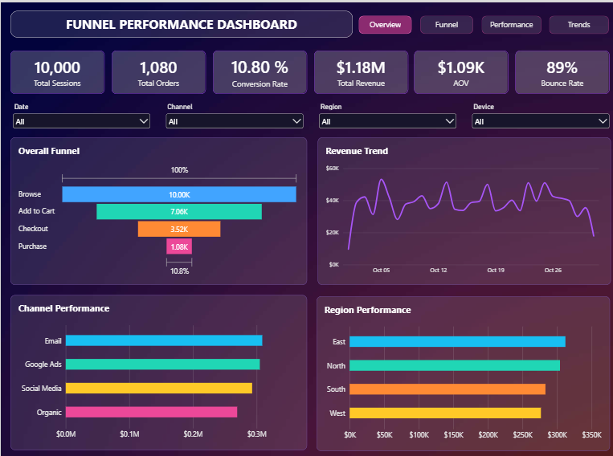

02 — Funnel Analysis | Where are users being lost?
Examines stage-level conversion and drop-offs, channel conversion performance, and purchase behavior across devices.

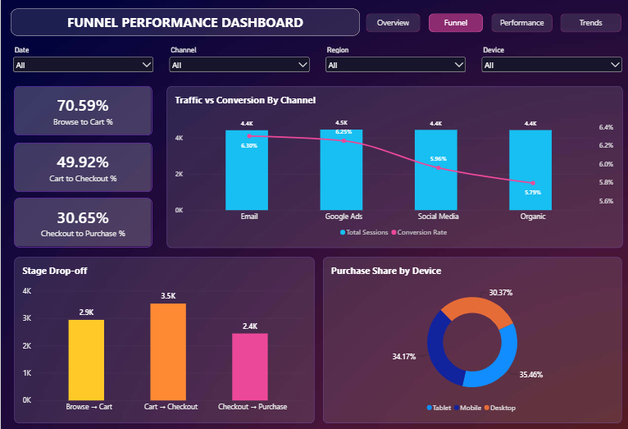

03 — Performance Analysis | What drives business performance?
Examines stage-level conversion and drop-offs, channel conversion performance, and purchase behavior across devices.
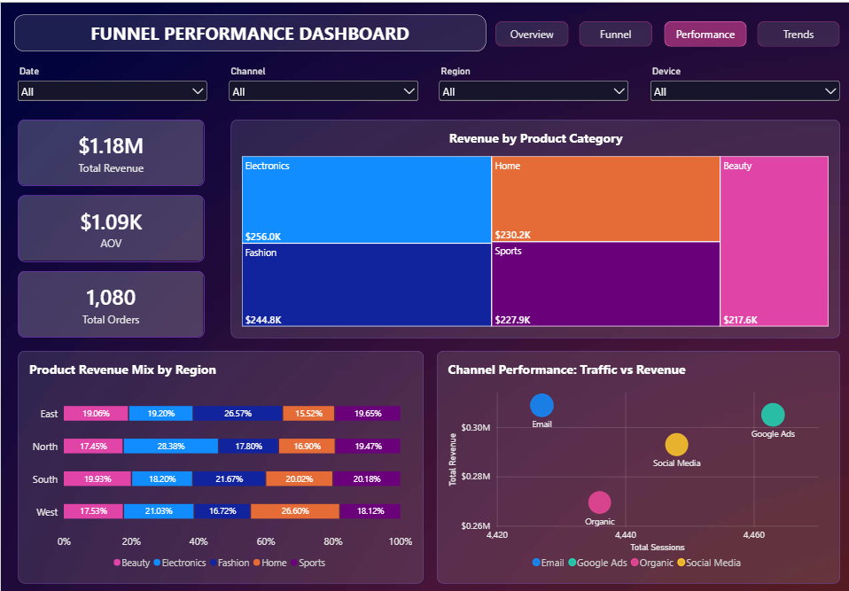

04 — Trends & User Behavior | When and how are users behaving?
Explores daily and hourly traffic and conversion patterns, including session duration and peak activity periods.

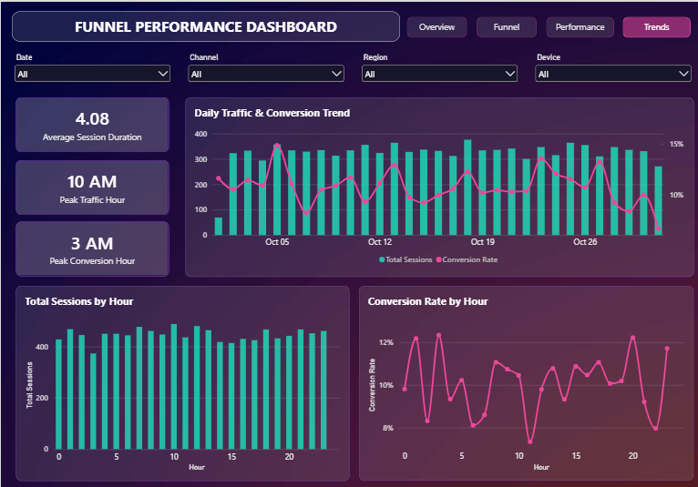

Key Business Insights

The combined Python and Power BI analysis revealed several important patterns across the customer funnel, revenue performance, and user behavior.

- Significant Funnel Leakage

Only 10.80% of the 10,000 sessions ultimately resulted in a purchase, indicating substantial opportunity to improve end-to-end conversion.
- Cart → Checkout Has the Largest Absolute Drop
The largest user loss occurred between Add to Cart and Checkout, where 3,535 sessions dropped from the funnel.

- Checkout Is the Biggest Conversion Bottleneck

Only 30.65% of checkout sessions progressed to purchase, making Checkout → Purchase the weakest stage by conversion efficiency.

- High Bounce Behavior

The session-level bounce rate was 89.20%, indicating that a large proportion of sessions were flagged as bounced and highlighting an important engagement concern.

- Deeper Funnel Progression Requires More Engagement

Average session duration was 4.08 minutes overall, while sessions ending in purchase averaged approximately 10.55 minutes, showing substantially higher engagement among converting sessions.

- Traffic Volume ≠ Conversion Efficiency

Peak traffic occurred at 10 AM, whereas the highest hourly conversion rate occurred at 3 AM, showing that the busiest period was not necessarily the most conversion-efficient.

Business Recommendations
Based on the funnel, performance, and behavioral analysis, the following actions could help improve customer progression, conversion efficiency, and overall business performance.
- Optimize the Checkout Experience

With only 30.65% of checkout sessions reaching purchase, investigate checkout friction such as unnecessary steps, payment failures, delivery charges, or form complexity.
Goal: Improve Checkout → Purchase conversion.
- Reduce Cart Abandonment

The largest absolute loss occurs before checkout, with 3,535 sessions dropping between Add to Cart and Checkout. Use cart reminders, clearer pricing and stronger checkout CTAs to encourage progression.
Goal: Recover high-intent users before they leave.
- Investigate High Bounce Behavior
With a 89.20% session-level bounce rate, analyze landing pages, traffic sources, page relevance, and user experience to determine what is driving early disengagement.
Goal: Improve initial engagement and funnel entry quality.
- Optimize Marketing by Performance, Not Traffic Alone
Since peak traffic (10 AM) and peak hourly conversion (3 AM) occur at different times, marketing decisions should consider conversion efficiency alongside traffic volume.
Goal: Allocate campaigns and resources toward higher-quality traffic periods.
- Prioritize High-Performing Segments
Use the channel, region, device, and product-category analysis to identify stronger-performing segments and prioritize them in targeting, merchandising, and campaign decisions.
Goal: Focus resources where they are most likely to generate business value.

